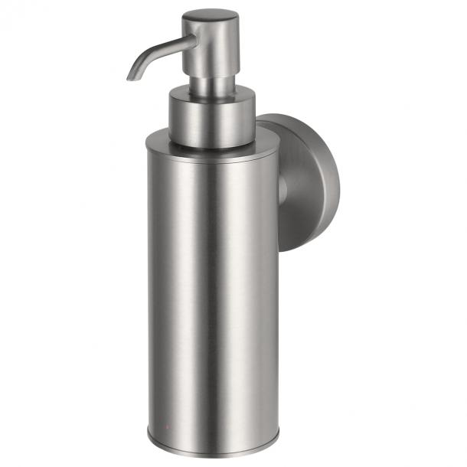

1208637

Information Haceka Kosmos Soap dispenser metal
- Brand nameHaceka
- Colour groupStainless steel look
- Dimensions5x10x17cm
- Item number1208637
- EAN number8718848203119

Product features Haceka Kosmos Soap dispenser metal
- Product titleHaceka Kosmos soap dispenser metal brushed
- Product descriptionThe design of Kosmos gives your bathroom a timeless, robust look. Back to basics: clean lines and modern.
- Width53 mm
- Depth100 mm
- Height170 mm
- ColourStainless-steel look brushed
- MaterialZamac, Stainless Steel - Inox
- Surface finishNickel Plated, Brushed
- Gloss levelMatt

