Haceka Kosmos toilet brush set metal mat black

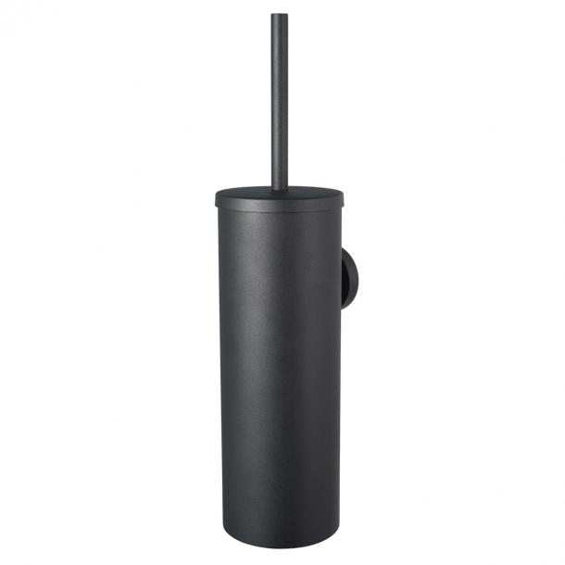

Information Haceka Kosmos Toiletbrush metal
- Brand nameHaceka
- Colour groupBlack
- Dimensions9x11x37cm
- Item number1208529
- EAN number8718848202037

Product features Haceka Kosmos Toiletbrush metal
- Product titleHaceka Kosmos toilet brush set metal mat black
- Product descriptionThe design of Kosmos gives your bathroom a timeless, robust look. Back to basics: clean lines and modern.
- Width93 mm
- Depth108 mm
- Height372 mm
- ColourBlack
- MaterialZamac, Stainless Steel - Inox
- Surface finishPowder Coated
- Gloss levelMatt

Other information Haceka Kosmos Toiletbrush metal
- Package contents1 Toiletbrush metal, 2 screws, 2 plugs, 1 mounting plate, warranty & assembly booklet
- Wholesale package1
- Fixing methodScrewed, Glued

