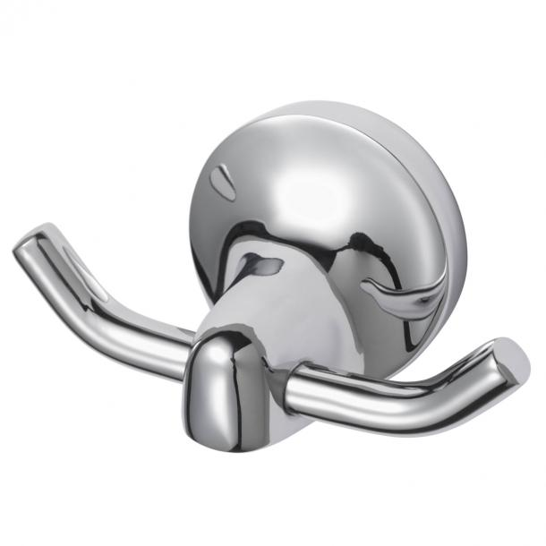

Information Haceka Aspen Hook double
- Brand nameHaceka
- Colour groupChrome
- Dimensions10x5x5cm
- Item number1208526
- EAN number8718848202006

Product features Haceka Aspen Hook double
- Product titleHaceka Aspen hook double chrome
- Product descriptionThe Aspen series from Haceka has a stylish look. This timeless series offers high quality at an attractive price.
- Width100 mm
- Depth46 mm
- Height53 mm
- ColourChrome
- MaterialZamac, Stainless Steel - Inox
- Surface finishChrome Plated
- Gloss levelHigh-gloss

Other information Haceka Aspen Hook double
- Package contents1 double Hook, 2 screws, 2 plugs, 1 mounting plate, warranty & assembly booklet
- Wholesale package1
- Fixing methodScrewed, Glued
- Scews in packageNo
- Glue in packageNo

